Lab Work 9. EDA (Exploratory Data Analysis)
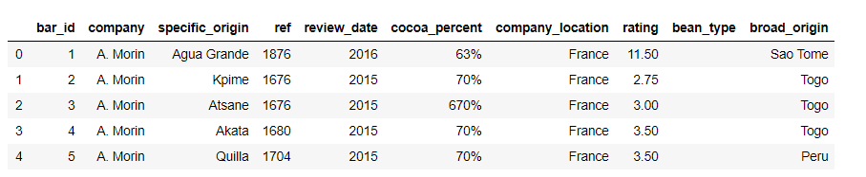
- Rename all columns as shown in the figure. (Refer to original worksheet for target column names.)

2. How many unique regions are there in the dataset?
3. How many values appear more than 10 times in the column?
4. Handle missing values in the `broad_origin` column by replacing them with None, then answer the following:
- How many unique values does the column contain?
- How many of those values occur more than 10 times?
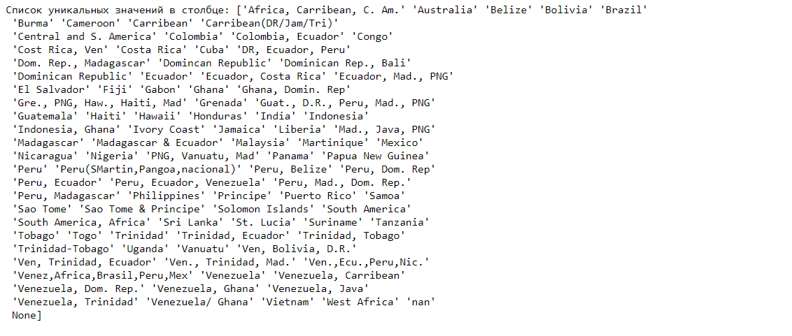
5. Note: The column contains many repeated values with different spellings.

This should be corrected using the helper function below:
def fix_countries(x):

if pd.isnull(x):

return x

if x == 'nan':

return None

if str(x).strip()=='':

return x

x = x.replace(' ', '')

x = x.replace('/', ',') # Venezuela/ Ghana

x = x.replace('&', ',')

if '(' in x:

x = x[:x.find('(')] #Peru(SMartin,Pangoa,nacional)

x = x.replace('Guat.', 'Guatemala')

if 'Ven' in x and 'Venezuela' not in x:

x = x.replace('Venez', 'Venezuela') #Venez,Africa,Brasil,Peru,Mex

x = x.replace('Ven,', 'Venezuela,') #Ven, Trinidad, Ecuador

x = x.replace('Ven.', 'Venezuela') #Ven., Trinidad, Mad.

if 'Ven' in x and 'Venezuela' not in x:

x = x.replace('Ven', 'Venezuela')

x = x.replace('Dom.Rep.', 'DomincanRepublic')

x = x.replace('DR', 'DomincanRepublic')

x = x.replace('Dom.Rep', 'DomincanRepublic')

x = x.replace('D.R.', 'DomincanRepublic')

x = x.replace('DominicanRep.', 'DomincanRepublic')

x = x.replace('Domin.Rep', 'DomincanRepublic')

x = x.replace('Domin.Re', 'DomincanRepublic')

x = x.replace('DominicanRepublic', 'DomincanRepublic')

if 'Jam' in x and 'Jamaica' not in x:

x = x.replace('Jam', 'Jamaica')

if 'Mad.' in x and 'Madagascar' not in x:

x = x.replace('Mad.', 'Madagascar')

elif 'Mad' in x and 'Madagascar' not in x:

x = x.replace('Mad', 'Madagascar')

elif 'Ma' in x and 'Madagascar' not in x:

x = x.replace('Ma', 'Madagascar')

if 'Hait' in x and 'Haiti' not in x:

x = x.replace('Hait', 'Haiti')

if 'Per' in x and 'Peru' not in x:

x = x.replace('Per', 'Peru')

x = x.replace('Nic.', 'Nicaragua')

x = x.replace('Gre.', 'Grenada')

x = x.replace('PNG', 'PapuaNewGuinea')

if 'Mex' in x and 'Mexico' not in x:

x = x.replace('Mex', 'Mexico')

x = x.replace('Haw.', 'Hawaii')

x = x.replace('Ecuad.', 'Ecuador')

x = x.replace('Ecu.', 'Ecuador')

if ',' in x:

x = x[:x.find(',')]

return x

cacao.broad_origin = cacao.broad_origin.apply(fix_countries)

After applying the function:
display(pd.DataFrame(cacao.broad_origin.value_counts()))
print('Значений, упомянутых более 10 раз:', (cacao.broad_origin.value_counts()>10).sum())
print("Уникальных значений:", cacao.broad_origin.nunique())
cacao.loc[:, ['broad_origin']].info()

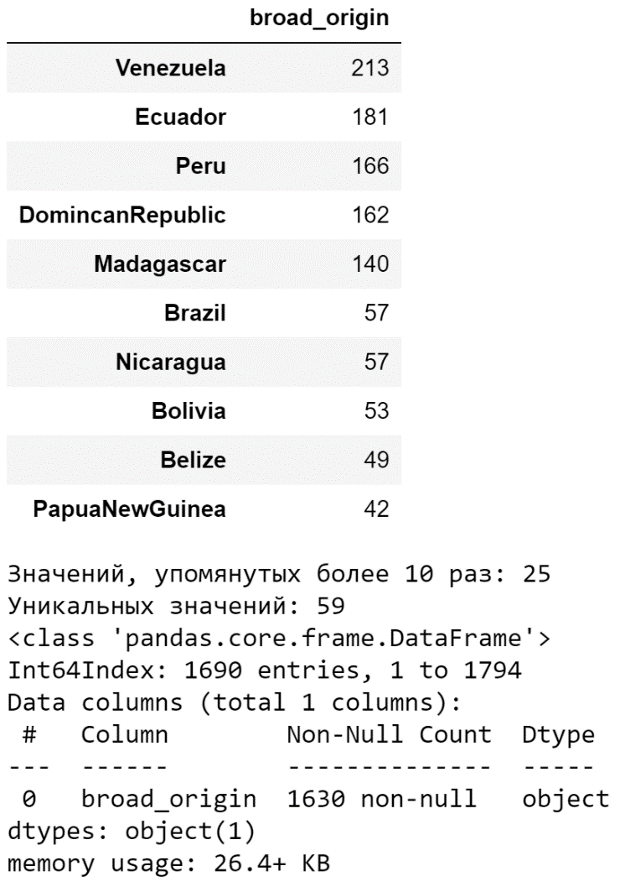
6. Build boxplots for the remaining categorical variables to consider: company, specific_origin, company_location, bean_type, broad_origin.
7. From the plots it seems that all parameters except `broad_origin` may influence the bar's rating. However, plots are only an auxiliary tool; statistical testing helps to determine whether differences are significant. Check whether there are statistically significant differences in rating distributions across categorical features using Student's t-test. Test the null hypothesis that rating distributions across different groups are indistinguishable:
def get_stat_dif(column):
cols = cacao.loc[:, column].value_counts().index[:10]
combinations_all = list(combinations(cols, 2))
for comb in combinations_all:
if ttest_ind(cacao.loc[cacao.loc[:, column] == comb[0], 'rating'],
cacao.loc[cacao.loc[:, column] == comb[1], 'rating']).pvalue \
<= 0.05/len(combinations_all): # Учли поправку Бонферони
print('Найдены статистически значимые различия для колонки', column)
break
for col in ['company', 'specific_origin', 'company_location', 'bean_type', 'broad_origin']:
get_stat_dif(col)

Question: Which parameters show statistically significant differences between groups?

